Intelligents Systems

1st Lab Session's Report

by StudentA and StudentB

Exercise 1: Chromosome genetic operators
Leave the programs in your directory. Make sure that you have given read access to your files.
Copy here the content of the file Exercise1.txt showing the results of the mutation and the crossover operators.
Mutation test 0:
Chromosome: fitness= 0.00, cities: 3 0 1 2 5 4
Chromosome: fitness= 0.00, cities: 5 2 1 0 3 4
Mutation test 1:
Chromosome: fitness= 0.00, cities: 5 1 4 2 0 3
Chromosome: fitness= 0.00, cities: 5 1 4 2 3 0
Mutation test 2:
Chromosome: fitness= 0.00, cities: 5 0 4 2 3 1
Chromosome: fitness= 0.00, cities: 5 0 1 3 2 4
Mutation test 3:
Chromosome: fitness= 0.00, cities: 1 3 4 0 5 2
Chromosome: fitness= 0.00, cities: 1 0 4 3 5 2
Crossover test 0:
Chromosome: fitness= 0.00, cities: 2 4 3 5 0 1
Chromosome: fitness= 0.00, cities: 4 0 1 3 2 5
Chromosome: fitness= 0.00, cities: 2 4 3 5 0 1
Crossover test 1:
Chromosome: fitness= 0.00, cities: 1 2 4 5 0 3
Chromosome: fitness= 0.00, cities: 0 4 1 5 2 3
Chromosome: fitness= 0.00, cities: 1 2 0 4 5 3
Crossover test 2:
Chromosome: fitness= 0.00, cities: 0 3 5 1 2 4
Chromosome: fitness= 0.00, cities: 2 4 0 3 1 5
Chromosome: fitness= 0.00, cities: 0 3 5 1 2 4
Crossover test 3:
Chromosome: fitness= 0.00, cities: 1 3 0 5 2 4
Chromosome: fitness= 0.00, cities: 1 2 4 3 0 5
Chromosome: fitness= 0.00, cities: 1 3 2 4 0 5
For each example, indicate what are the boundaries of the segment selected by the operator.
Mutation test0 : 0-4
Mutation test1 : 4-5
Mutation test2: 2 -5
Mutation test3 : 1-3
Crossover test 0 : 0-5
Crossover test1 : 0-1
Crossover test2 : 0-4
Crossover test3 : 1-1

Exercise 2: Population evolution on a circle
Leave the programs in your directory. Make sure that you have given read access to your files.
Copy here the content of the file Exercise2.txt showing the evolution of the shortest route.
Insert here the image showing the best route obtained.

Mutation rate: 0.100, Population size: 50

Generation: 0, population size: 50, Round-trip length: 4287.719, best 4287.719

Generation: 1, population size: 50, Round-trip length: 4205.742, best 4205.742

Generation: 3, population size: 50, Round-trip length: 3915.416, best 3915.416

Generation: 7, population size: 50, Round-trip length: 3281.153, best 3281.153

Generation: 14, population size: 50, Round-trip length: 3139.779, best 3139.779

Generation: 16, population size: 50, Round-trip length: 3066.925, best 3066.925

Generation: 17, population size: 50, Round-trip length: 2926.060, best 2926.060

Generation: 22, population size: 50, Round-trip length: 2842.408, best 2842.408

Generation: 27, population size: 50, Round-trip length: 2788.430, best 2788.430

Generation: 28, population size: 50, Round-trip length: 2734.300, best 2734.300

Generation: 31, population size: 50, Round-trip length: 2536.023, best 2536.023

Generation: 34, population size: 50, Round-trip length: 2468.658, best 2468.658

Generation: 35, population size: 50, Round-trip length: 2458.647, best 2458.647

Generation: 37, population size: 50, Round-trip length: 2256.828, best 2256.828

Generation: 40, population size: 50, Round-trip length: 2158.216, best 2158.216

Generation: 41, population size: 50, Round-trip length: 2149.261, best 2149.261

Generation: 43, population size: 50, Round-trip length: 2142.057, best 2142.057

Generation: 48, population size: 50, Round-trip length: 2040.193, best 2040.193

Generation: 50, population size: 50, Round-trip length: 2025.775, best 2025.775

Generation: 54, population size: 50, Round-trip length: 2023.122, best 2023.122

Generation: 56, population size: 50, Round-trip length: 1923.911, best 1923.911

Generation: 58, population size: 50, Round-trip length: 1913.568, best 1913.568

Generation: 61, population size: 50, Round-trip length: 1811.704, best 1811.704

Generation: 70, population size: 50, Round-trip length: 1809.051, best 1809.051

Generation: 74, population size: 50, Round-trip length: 1695.024, best 1695.024

Generation: 82, population size: 50, Round-trip length: 1695.024, best 1695.024

Generation: 91, population size: 50, Round-trip length: 1481.591, best 1481.591

Generation: 147, population size: 50, Round-trip length: 1478.938, best 1478.938

Generation: 154, population size: 50, Round-trip length: 1367.203, best 1367.203

Generation: 222, population size: 50, Round-trip length: 1251.707, best 1251.707

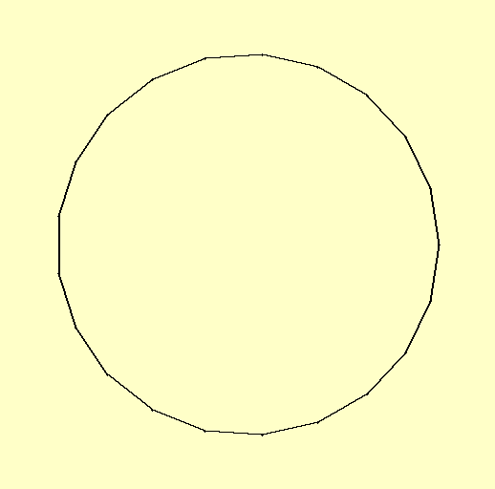

Exercise 3: Population evolution on cities in France
In this exercise, run the experiments 3 times (with different random starting points) for each set of parameter values and provide all 3 results.

Mutation rate
With a population size of 100, show the table of results for the values of the mutation rate 0.01, 0.1, 0.5.

Best route
Indicate here the best route in France found in your experiments, and insert the corresponding image here.

